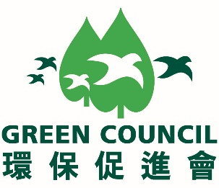

To: Hong Kong Green Day Secretariat Office

Room 703, New World Tower 1,

18 Queen's Road Central,

Hong Kong

Attention: Mr. Jason Yip / Ms Sendy Chan

Fax: +852 2810 1998

Email: [hkgreenday@greencouncil.org](mailto:hkgreenday@greencouncil.org)

**REPLY SLIP**

**Green Council – Hong Kong Green Day**

**Supporting Organisation Invitation**

We are pleased to confirm that our Institute　□ will　/　□ will not　accept your invitation to join as a supporting organisation of the captioned event.

(✓ where appropriate)

|  |  |  |  |
| --- | --- | --- | --- |
| Name of Organisation: |  | | |
| Contact Person: |  | Contact Tel: |  |
| Fax no.: |  | Email address: |  |
| Signature and chop: |  | Date: |  |

Remarks: Please email your Organisation’s logo in AI format to [hkgreenday@greencouncil.org](mailto:hkgreenday@greencouncil.org) by **26 February 2018.**

If you have any questions, please do not hesitate to contact Mr Jason Yip, +852 2810 1122 ([hkgreenday@greencouncil.org](mailto:hkgreenday@greencouncil.org)).